# **Tutorial – Integrating Azure Machine Learning Services with Microsoft Excel**

## **Introduction**

The goal of Machine learning is to be able to build and distribute models that can be used in business processes and by business uses.

The most used Business Analyst tool used worldwide is Microsoft Excel, often used for adhoc analysis, however many business make extensive use of Excel in their business processes.

Azure Machine Learning Studio has a Microsoft Excel add-in which is yet to support Azure Machine Learning Services, however Excel has many features than can allow access to remote web services.

## **Getting started**

To accompany this tutorial, we have provided a Jupyter notebook and an Excel Spreadsheet which uses a model based on the Boston House Price Dataset.

The approach we will use in this tutorial is to use Excel Macro feature which is powerful and very customisable. Macros can easily be executed using keyboard shortcut.

To ensure that Macros are only executed with permission of the user, macros in Excel are disabled when opened. To enable Macros Click Enable Content.

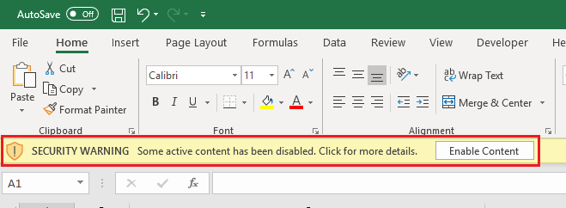

The main worksheet comes with a table already loaded with sample Boston House price features.

Note the final column of the table is called “Label” or “Predict”, this will act as the label and scored results will be placed in this column.

In order to complete the Score request the Macro will need to know the URL of the Scoring Webservice. The Macro picks up from a named Cell called WebURL as shown in the image below. Alternatively, the URL can be hard coded into the Macro.

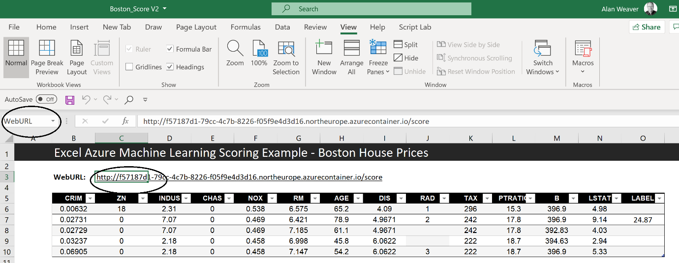

To make a prediction select rows in the table, you can select the whole row or any column in that row. Hold CNTRL-Shift and S, the label column should populate for the selected rows.

## **Technical description.**

The macro can use any Azure machine learning Web service. For the purpose of this demonstration we are not using any authentication. However it is important to know the features required for the features and the order of those features.

The data that will ne sent to the scoring service will need to be in an Excel Table. They easiest way to create a table is to use the Format as Table Icon, normally under the Home Menu.

The Table will need to have columns for all the features required to score as well as additional column called either “Label”, “LABEL”, “Predict” or “PREDICT”. This column will be used the receive the response.

When the Keyboard Shortcut is executed the associated Macro will run. This this case it will execute a Subroutine called “Score()”. You can view Macros buy clicking the Macros Icon, normally under the View Menu.

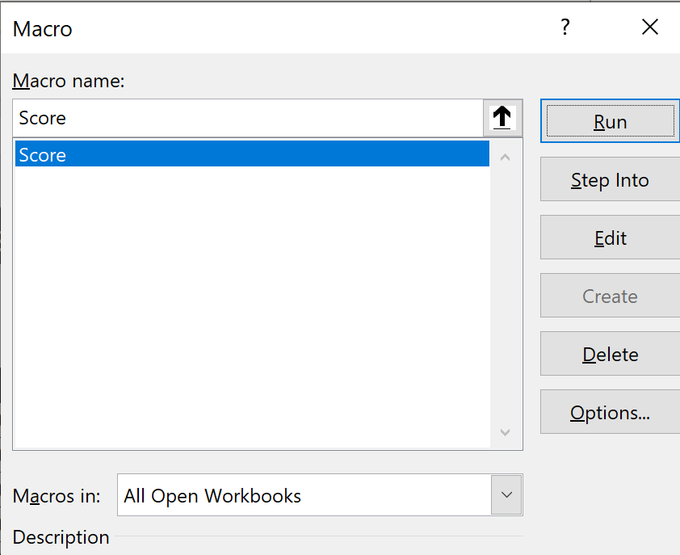

The Keyboard shortcut can be set under the Options button.

The Score Subroutine collects the data from the table extracting the label column and makes a request to RunScore Function which executes the HTTP request

The function we will use to execute the scoring request is shown below.

**Url = WEBURL**

**Set objHTTP = CreateObject("MSXML2.ServerXMLHTTP")**

**objHTTP.Open "POST", Url, False**

**objHTTP.setRequestHeader "Content-type", "application/json"**

**objHTTP.send (sbody)**